Trakehners Australia Inc is proud to be conducting a Grading Tour in 2023. Again we are again hosting Matthias Werner, representative of the Trakehner Verband eV to consider and score all our entered Trakehner horses, whether for registration into the Trakehner Verband eV, Trakehners Australia or for general assessment of an already registered horse.

As well as scoring the entrants, Matthias will be speaking to each owner/breeder and can make time to advise on breeding options for your mares, and speak to you about your own breeding goals and how to progress with them.

The focus in 2023 is on registration and breeding guidance, hence we will not be conducting a full suite of “show” classes, but will be making awards based on the scores to recognise excellence with horses scoring 75% or more eligible.

You need to be a Trakehners Australia Inc member to participate, so if you are not already a member you need to submit your membership via the website asap, and no later than concurrently with this tour application.

For the tour itself, you need to complete the on-line Stud Stop booking form, and then on-line entry forms for each horse to be graded. For Mares, foals and stallion that are not previously registered with TA Inc or the TV, Tour entry will also require the necessary registration documents to be completed and submitted on-line for TA Inc registrations. For TV registrations, please contact the TA inc Registrar, on registrar@trakehnersaustralia.com who will be your liaison point between TA Inc and the TV.

THIS DOCUMENT sets out guidelines, and the “gold standard” of presentation.

We know that not everyone has an enclosed arena, capability and time to plait mares and foals etc, and the excessively wet climatic circumstances of 2022 expected to continue into 2023, so do not despair if you are not able to reach the recommendations. Cleanly presented horses/foals in a reasonably level enclosed small paddock area of at least 20 metres by 30 meters is the minimum requirement. We understand.

Regards,

The TA Inc Committee
- Warren Schutz, President
- Jill Innes-Irons, Vice President
- Michele Armstrong, Secretary
- Denise Rutzou, Registrar
- Rebecca Allen, committee member.

Guidelines for entry
Purebreds:
- For Trakehner Verband Registration: Grading scores are for mares and foals sought to be registered into the TV
    - All mares must be registered with a breed society and a copy of their registration papers must be provided to TA to sent to the TV for pedigree approval well in advance of the tour.
    - All owners must be financial members of TV, and of TA
    - All horses must be DNA tested (already or sample taken on the tour day)
    - All horses must be microchipped – this can be done by the TV Kommissioner on the day.
    - Entry is open to pedigree approved:
  - Purebred mares 3 years and over
  - Thoroughbred mares 3 years and over
  - Purebred Arabian mares 3 years and over
  - Anglo Arab mares 3 years and over.
  - Foals that are the progeny of a TV Studbook 1 mare and a TV Licenced Stallion.
- For Trakehners Australia Registration: Grading scores are for horses sought to be registered into TA
    - All owners must be financial members of TA
    - All horses must be DNA tested (already or sample taken on the tour day)
    - All horses must be microchipped BEFORE the tour day and you must have the microchip stickers or number available to check.
    - Eligible horses:
  - Purebred mares 3 years and over
  - Thoroughbred mares 3 years and over
  - Purebred Arabian mares 3 years and over
  - Anglo Arab mares 3 years and over.
  - Purebred Trakehner stallions or colts over the age of 3 years (born before 1 August 2020)
  - Pureblood foals that are the progeny of:
    - pureblood mares (or Thoroughbred, Arab, Anglo Arab mares that are pedigree approved by the TA); and
    - stallions that are registered with TA or TV (or in special applications that are pedigree approved by TA or TV as purebloods. )

Purebred Trakehner Geldings:
Your gelding may already have been registered with TA as an entire foal. If so, all you need to do is advise the TA Registrar that your horse is now gelded. His registration will then be changed from foal register to gelding register. It is not necessary to have a gelding assessed, but, as for partbreds, assessment scores can be a useful marketing tool if you are considering sale of your horse

Partbreds with 25% Trakehner blood.
- Trakehner partbreds for TA registration purposes are mare, foal, stallion or gelding partbreds with at least 25% Trakehner blood as authenticated by the TA Registrar on the stud papers.
- Partbreds do not need to be assessed in order to be registered into the TA partbred register.
- You may however wish to have them assessed and scored to have a comparison of quality of conformation and gaits to the general population of Trakehners. Scores can be a useful marketing tool if you are considering sale of your horse, and as a guide if you are considering breeding your partbred mare or stallion
- Partbreds will be scored to the same standards as purebloods.

Presentation guidelines:
A 3 stage process for mares and for foals at foot:
- Presentation and measuring
- In hand workout
- At liberty workout
A 4 stage process for 3-4 year old stallions/colts for Preliminary Approval for Breeding.
- Adds a free-jumping component
A 5 stage process for stallions over 4 years of age, for Preliminary Approval for Breeding.
- Adds a ridden component
Stage 1. Initial presentation to classifier and measuring:
- Your mare or gelding may be presented either in a bridle with noseband/cavesson or in a well fitting halter. If using bridle and reins, make sure you have snap links on the reins so you can to remove reins fast for liberty presentation.
- For stallions, you should present in a bridle with noseband/cavesson.
- All horses must be presented without boots or bandages for the initial presentation.
- Preferably, plait the mane including the forelock. Presentation with a well groomed appropriate length mane is acceptable, but remember, this may not show off your horse’s neck to full advantage.
- Practice with the horse getting them used to being measured at the wither and measuring her canon bones if being graded or classified.
- Walk the horse towards the Grading Commissioner, halt about 3-4 metres in front of them, showing the side of the horse. Ideally, the legs facing the assessor are supposed to be “outside” (front leg forward and hind leg back), the other legs away from the classifier must show between then. This way the Grading Commissioner can see all four legs.
- A helper may stand a few meters in front of the horse (or mare and foal) to get their attention with a whip or flapper to make sure they stand up with head up and ears pricked for best impression.
- For adult horses, the Grading Commissioner will measure the height of the horse and cannon bones for recording on the registration documents.

Stage 2. In hand workout:
- All horses must be presented without boots or bandages for the in hand presentation.
- It is desirable that you set up a “course” as described, but not compulsory.
- When presenting the extended walk, make sure the reins are loose and the neck is not restricted. Walk swiftly.
- When at trot, you will need to run fast! Fast enough for the horse to show its proper big stride, but not so fast it breaks into canter. Train first to know your horse’s optimum speed.
- You will need to have an arena or a flat paddock area, safely fenced for foals and adult horses at liberty. The area should be at least 20m wide x 30m long to allow for showing the horse’s paces best at liberty.
- For the in-hand workout, you may be on a smaller area but still around 20x20 metres to give distance to properly show paces. . You may choose to use ground poles or cavalletti to set up a presentation layout as shown below. It is not a requirement to set up such a course, but it may assist you when presenting your horses and is a presentation standard to aspire to.
- The grading commissioner will direct you when to commence and when to change paces.
In Hand Foal presentation guidelines:
- There are no strict rules for presenting foals, but these hints may help to leave a good impression:
- For foals, the in hand workout patters shown above for adult horses may be used or a variation as requested by the Grading Commissioner on the day.
- The foal should either be plaited, or be presented with a well groomed mane.
- Lead the mare (presented as above) and the foal (wearing a suitable tidy headcollar) into the ring. Let them stand as quietly as possible and make sure the assessor can see the foal from the side (Head up, not nursing).
- Make sure the foal is kept between the assessors and the mare at all times.
- When you are asked, take off the foal’s head collar and lead the mare only.
- Follow the instructions of the Grading Commissioner. They may require the same in-hand pattern as for the in hand workout as for adults, or otherwise as directed.
- It is usual to go in a clockwise direction, leading the mare so you are on the outside, then the mare and hopefully the foal beside the mare in full view of the assessor!
- The for the liberty presentation, take the reins off the mare and let both run freely.
- It is a good idea to have a second person (or sometimes even a third) with a whip to carefully “push” the horse from behind. Make sure not to do too much. Practising at home gives a good feel of how much the individual horse/foal needs. This second person can also stand in front of the horse when presenting and try to get its attention to make it raise the head and neck and prick ears.

Proposed pattern for in-hand presentations
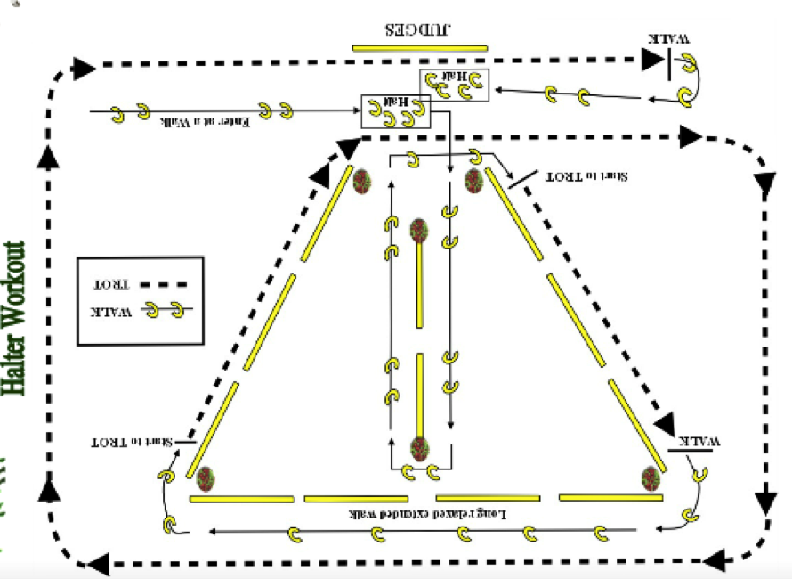

Stage 3. At liberty workout:
- You will need to have an arena or a flat paddock area, safely fenced for foals and adult horses at liberty. The area should be at least 20m wide x 30m long to allow for showing the horse’s paces best at liberty.
- Remove the reins on command of the assessor.
- Horses may be presented at liberty wearing boots or bandages, but you will have be quick at applying them after the in hand presentation so as not to hold up the Grading Commissioner.
- The Grading Commissioner will want to see the horse travelling both clockwise and counter-clockwise.
- Try to let the horse develop a relaxed trot, then increase the pace on a straight line.
- Let the horse canter on both sides, remaining as calm as possible.
- It is generally a good idea or even necessary to have a second person (or sometimes even a third) with a whip to carefully “push” the horse from behind. Make sure not to do too much. Practising at home gives a good feel of how much the individual horse/foal needs. This second person can also stand in front of the horse when presenting and try to get its attention to make it raise the head and neck and prick ears.

Stage 4. Free jumping OR Jumping under saddle – required for colts or stallions:
- For colts that are not yet broken in, free jumping must be done.
- For stallions that are broken in, you may elect to have their jumping ability assessed either under saddle or in free jumping.

Free jumping guidelines:
- Preparation: It is highly recommended that you train your colt/stallion for some weeks in the art of free jumping to show him at his best. Preferably train him in the same environment/facility where he will be presented.
- Free jumping is done in a jumping lane, separated from the main arena by a fence, poles or tape division.
- The jump lane is set up to be moved through anticlockwise, that is on the left rein.
- The jumping lane contains three elements, being:
  - a cross pole fence (0.5m high)
  - followed by an upright (0.7m high)
  - followed by a parallel oxer (1m wide x 1m high)
- The first two fences are normal show jumping poles; the third fence may have some infill or panels.
- A distance of 7.5m between the obstacles will suit most horses without alteration. Adjustments of no more than 0.5m each way may be made for long or short striding horses.
- For fairness to all horses presented, the arrangement of the jumps are not to be altered. The handler may, however, increase the height of the all three fences at his or her discretion during the grading or at the request of the Grading Commissioner.
- A short warm-up period is allowed when the colt/stallion may be put through the jump lane with lowered poles.
- For the Grading itself, the colt/stallion is required to go through the jump lane four (4) times, with the last jump (the parallel oxer) at a minimum height of one (1) metre.
- Failing to complete the 4 jumping runs or failing to jump clear is not an automatic “fail” but will of course be reflected in the scores for the jumping phase.

Jumping under saddle guidelines:
- You must ensure your jumping course contains at least fences that replicate those in the jumping lane guidelines. You may elect to have more fences than that, and/or at increased distances, heights and configurations.
- You must comply with any particular requests for jump configuration or order made by the Grading Commissioner.

Stage 5. Ridden workout – required for stallions over 4years of age, optional for all others:

- Plan your own workout to suit your horse’s level of training and to best show trainability and freedom of movement.
- All horses are to be ridden in a snaffle bridle.
- Horses may be booted or bandaged for the ridden workout.
- Different stages of straining will be taken into account when judging.
- The following is what you MUST show in your workout:
  - Enter at WALK and HALT in front of judge.
  - WALK a 20 metre circle in working frame
  - LENGTHEN WALK on a long rein across the diagonal
  - TROT a figure of eight in working trot
  - LENGTHEN TROT across the diagonal. This to be done on both reins.
  - CANTER a figure of eight in working canter. Change of lead may be done through walk, trot or flying change.
  - LENGTHEN CANTER along side of arena showing clear transitions from and to working canter before change of lead. Change of lead may be through walk, trot or flying change.
  - When finished, WALK to the judge and HALT.
- The grading commissioner may ask you to repeat or do additional movements to best score your horse.

The Trakehners Australia Inc Committee, with approval from the Grading Commissioner, may exercise discretion to exempt a horse from any movement in any stage of grading based on veterinary or injury issues. You should give advance notice to the TA Inc Registrar as soon as you are aware that you may need to seek such exemption. A veterinary report may be required to establish whether the injury constitutes a hereditary disorder, and if so the TA Inc Registrar will advise in writing.

